Code-

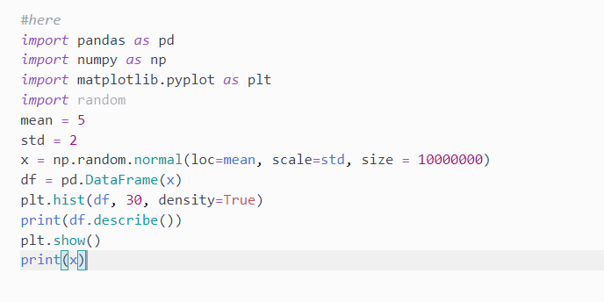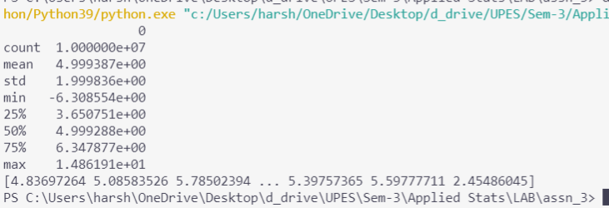

Plot the distribution.

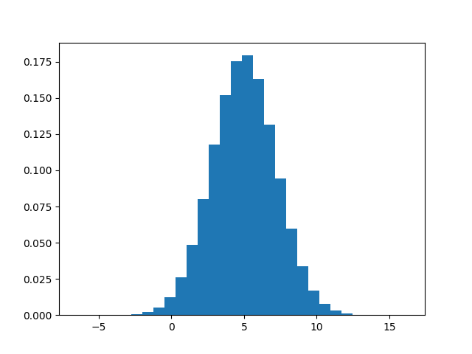

Give the summary statistics

When we talk about a random variable, usually denoted by X, it’s final value remains unknown. The random variable is “X”. Not the output of X. Not the output of random.random(). Just X, with possible outcomes and associated probabilities.

The Normal Distribution is one of the most important distributions.

It is also called the Gaussian Distribution after the German mathematician Carl Friedrich Gauss.

It fits the probability distribution of many events, eg. IQ Scores, Heartbeat etc.

Use the random.normal() method to get a Normal Data Distribution.

It has three parameters:

loc - (Mean) where the peak of the bell exists.

scale - (Standard Deviation) how flat the graph distribution should be.

size - The shape of the returned array.

The mean is considered to be the Measure of location for the data which is given to be **5**

The standard deviation is considered to be the spread of the data which is given as **2**

The summary statistics for graphical representation is done above in the output section using **Histogram.**



All the summary of the calculated data.

* 68% of the data falls within one standard deviation of the mean.
* 95% of the data falls within two standard deviations of the mean.
* 99.7% of the data falls within three standard deviations of the mean.